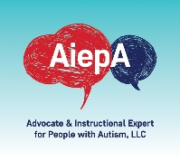
CONFIDENTIALITY RELEASE FORM
AUTHORIZATION FOR THE RELEASE OF EDUCATIONAL RECORDS AND INFORMATION
I, ________________________________, authorize representatives of __________________________________ (name of school/school district) to release and discuss the educational records and information of:____________________________ (student’s name) to the following individual:
Mo Buti
AiepA: Autism and Instructional Expert for People with Autism
918 W Agatite Apt G Chicago, Il 60640
312-316-2884
mobuti@aiepautism.com
Parent Signature: ______________________________________________________
Date of signed release:___________________________________

